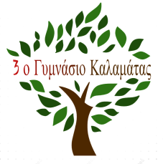

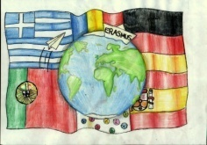
Erasmus+ "Odyssey - Migration and its Influence on Teenagers”

2nd TTLA – Kalamata, Greece (22nd- 28th April 2018)
Meeting Programme

Sunday, April 22nd - Arrival of delegations
Monday – 23rd April
9:30 - welcoming ceremony
- division of students into international teams
- Ice breaking activities
11:30 - break for brunch-
12:00 - Presentations – Germany, Portugal, Romania
13:30 - Immigration song and dance

Tuesday – 24 April
8:30 - Departure for Marini Farm
9:00 - Arrival at the farm. Presentations Migrations patterns in the present- Germany, Portugal, Romania
11:00 - Break for brunch
11:45 - Workshop- theatre games
14: 00 - Lunch
15:00 - depart for Kardamyli
15:30 - Visit the old town of Kardamyli
16:45 - Free time to walk around the village
17:45 - Leave Kardamyli
18:45 Return to Kalamata
Arrival in Kalamata around 19:30

Wednesday -25 April
8:00- Depart from school for the Lahaina
11-00 Arrival in Lehaina
11:15 – 13:00 Visit the LM Village
13 :30 Castle of Hlemoutsi. Lunch
15:00 Visit the ancient site and the museum of Ancient Olympia
18:00 - Depart from Ancient Olympia
20:30 - Return to Kalamata

Thursday – 26 April
9:00- Meet at school .
9:15 - Work in international groups: Analysis of comments social media
10:45– snack / coffee break
11:00 – Presentations of comments on social media social
11:40 - exhibition about famous migrants and personal object
12:30 – leave for city centre
12:40 - Walk through the old town: Church of the Sts Apostles, Castle and Monastery
14:45 - Students go home – teachers lunch
End of work
Afternoon is free
Evening- Beach party for students and teachers

Friday - 27 April
9:00 – drawing of graffiti in teams for students/ Meeting for teachers
11:30 - snack / coffee break
12:00 Continuation and presentation of art activities
14:00 – End of Activities
18:30 - Dinner with parents and families

Saturday - 28 April
Departure of foreign delegations

