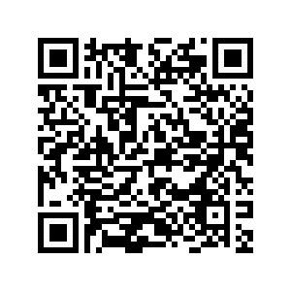
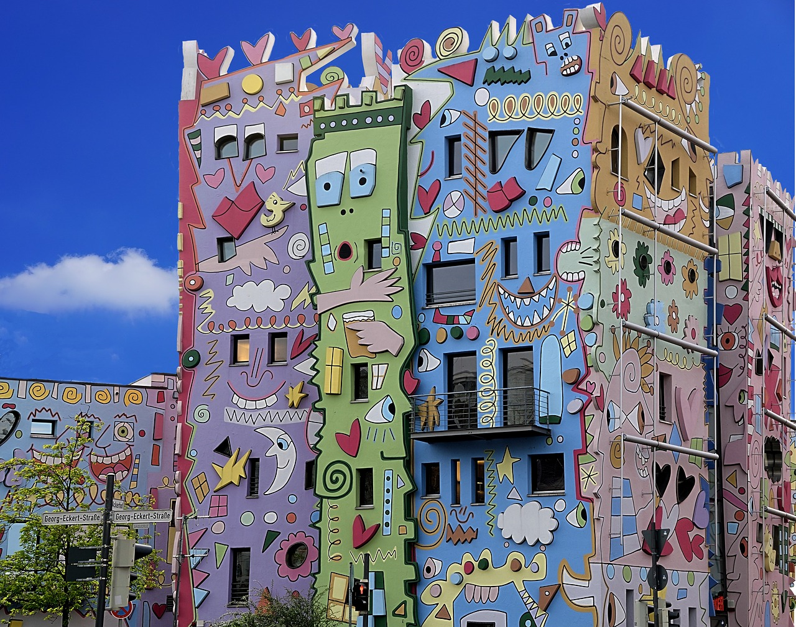
Find places of interest in Braunschweig.
Use your smartphones.
Enjoy the rally!

Extra Task:
Find 5 places (shops, restaurants, snack bars, etc.) that show that Braunschweig is a place of immigration. Prove that you were there by taking a photograph, bringing a menu or something else.

