THIS IS THE SKIT PRESENTED AT THE LTTA 5 IN GERMANY

*Doorbell rings *
Jenny:Oh, Hey guys
Papa:Hi
Stauroula:How are you Jenny, Happy birthday to your grandma.
Jenny:Oh, thank you! Come inside, here, sit on the couch
*They sit on the couch*
Papa:Oh,what is that?
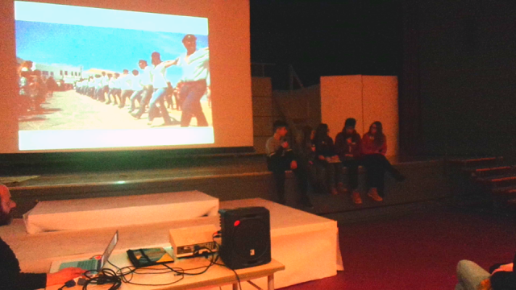
Jenny:It's a family photo album.
Stelios:Oh, can we see it?
Jenny: Of course
*They flip through the album*
Jenny:So... This is from my cousin, Alexandros's wedding.
Melia: what's that dance called?
Stelios:I think it's Hasapiko. It's a traditional popularist dance from our ancestors from The Asia Minor
Melia: But, that's a Greek dance, how is it possible that your Asian Minor ancestors knew the steps?
Stelios: Hasapikos stems from The Asia Minor. It was danced only by men and it was named after the Hasapides, that is the butchers of the Byzantium.
Stauroula: How come we dance it here?
Stelios: No one doubts the fact that it's a traditional dance. But after it became wide spread as with the Zeimpekiko, it developed into something different.
Stauroula: The truth is that, in this day and age it's danced throughout Greece and it's considered to be one of the most representative Greek dances.
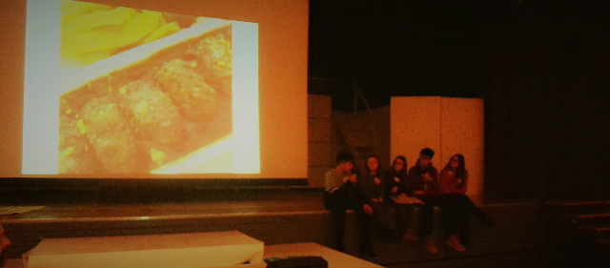
Jenny: Fortunately, or maybe unfortunately, the same holds for the Zeimpekiko.
Melia: What do you mean with Zeimpekiko? Can you explain it?
Stelios: It was named after the Islamized Greek culture of the Zeimpekides. It spread in Greek cities at the end of 19th early 20th century.
Papa: I've heard that it symbolizes the connection between the soul and body and God with humans
Stelios: At any rate both dances were brought over to Greece when with the exchange of populations in 1922 many Greeks from Turkey came to Greece as immigrants *

FOOD Jenny: Are you hungry? I brought you some soutzoukakia. My grandma made them from a traditional recipe taught to her by her mother, back in the Asian Minor.
Melia: I've heard that soutzoukakia is a recipe brought over from there.
Papa: I suggest we order pizza. It's a well known Italian food that all Greek know. Stauroula: let's get a salad too
Everyone: Okay! *Pizza comes* *They start eating*
Melia: Hmmmmm,I think the salad needs some salt,can you bring me some, Jenny? Jenny:Fine... *Some salt falls down*
Stelios:Oh...I've heard that if salt falls on the floor is a bad sign but it seems strange to me, so I don't know if it is true.
Melia:Yes it's true! My grandmother told me that when she was getting ready to get married, someone accidentally dropped salt on the floor, and everyone was worried that something bad would happen. She said the wedding rings were lost. She was from Smirni in Asia Minor and came over to Greece in the early 20th century
Stelios:Seriously, Yes! That's is what I've heard.
Stelios:I also know that Western cultures consider the number of 13 unlucky but in Greece we consider it unlucky only if it's on a Tuesday Papa:1 know that, so what?
Stauroula: Well apparently it too is a superstition from the Asia Minor.
SPORTS Papa: What's that noise
Jenny:There's a game on tonight
Stauroula:Oh really,who is playing against whom?
Jenny:Aek and Panionios.
Melia:Aek stands for what? Stelios: Athletic Union of Constantinople or Istanbul Melia:Oh, like PAOK?
Stelios:Yes PAOK stands for Athletic Club of Istanbul. They are called that because they were founded by the Greeks of Istanbul
Stauroula:So, guys, I have a question ,who is that (points at the screen)...
Jenny:He's a foreign player who plays for a Greek football team
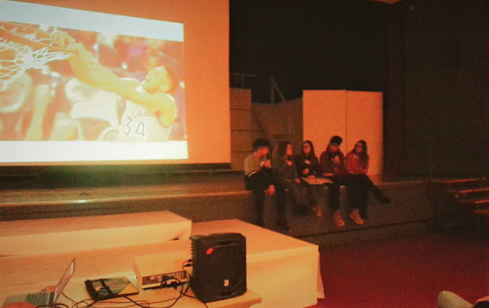
Melia:Oh, same as Antetokoubo?
Papa:No, Antetokoubo is not a foreign player. It's just that his parents were immigrants from Nigeria. He was born in Greece and has offered a lot to the Greek basketball community. Now he plays for established teams such as Milwaukee Bucks
Melia:Now that you mention it, I know many foreigners and immigrants who have contributed to the development of sports in Greece
Pap: mmhm..
LANGUAGE
Jenny: *sighs* I'm bored, what do you guys want to do?
Pap: Let's play something.. Do you want to play hang man?
Stauroula: Great idea! Who's going to go first?
Stelios: Me! Bring me a piece of paper and a pen please *writes down the word*
Everyone: *plays the game*
Jenny: Oh, I got it! "Mbaltás"
Melia: "Mpaltás"? What is that?
Stelios: It's a knife butchers use..
Melia: Hmm.. And where did it come from?
Pap: I think it's Turkish
Stelios: You're right, Greeks from The Asia Minor who were influenced by the Turks brought it here when they immigrated to Greece, like so many other words such as, for example, the word "yoúRi" which means good luck, the word "kaiki" which means fishing boat and many more
Melia:Oh like the word "kaßyás" which means fight..
Stauroula: Yes.. We have so many Turkish words in our vocabulary huh..
Melia: Yeah.. My turn now *writes down a word* Everyone: *plays the game until they loose*
Melia Oh, and what is that?
Jenny: Oh, keep that for later, it's very touching... Melia: Okay.
Melia:Of course.

*They arrive at Papa's house*
Melia: I have never seen this house before when did you move out?
Papa: It has not been long since then -There are a lot of differences between your house and the other houses. What did you use to build it?
Papa: It is made of stone, some Albanian built it and that is why the architecture is different from the other houses.
Stelios :- Why did you choose an Albanian and not a Greek?
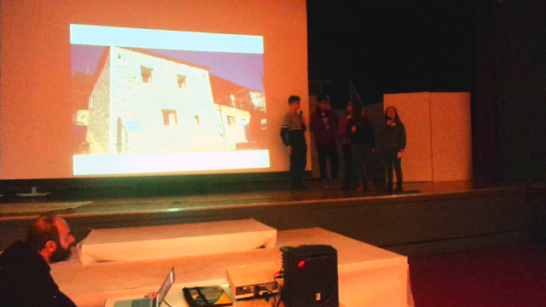
Papa: -There are a lot of reasons. Nowadays Greeks don't accept these jobs because they consider them inferior. Moreover, Albanians take less money than Greeks and they are hard working. They work the stones only using their hands and not machines. -Yes immigrants help in the development of our economy. Especially in two specific areas. The first is Agriculture. In our area immigrants are the ones that actually help in the collection of the olive harvest.
Stelios-Yes you are right. Last weekend we were gathering olives in my village and my grandpa had hired Romanians to help us. Furthermore they also help in the gathering of other local produce and the care of the elderly
Melia: The second field where immigrants contribute is tourism. The tourist industry is very important to our country but most of the menial jobs like cleaning personnel, gardening and maintenance in general are held by immigrants.
Papa: Mhm.. I have to go now
Stelios: Oh right.. See you later!
Pap: Bye guys..
Everyone: Byeee
Melia: Oh, now that I remember, what's this I found in the album Jenny?
Jenny: It's a letter my grandma wrote when she came over to Greece.
Stelios: Oh, let me read it...
Melia: Here you go.

I write this talisman letter.
And I write it with freedom,
not because I have to.
If I live, I will see you.
If I die, you will have my talisman ...
I wish this pencil could express the hardships that my people Syria
face in their lives.
I long for freedom and I love my homeland deeply. Freedom has planted hope in the souls of the children that shed their blood for it. This hope
is what the forces of war tried to ravage.
Now I feel like a street child because I don't know where I will
be next.
I hope that in the future I will see better days; that I will be a
doctor, a surgeon. I wish to make a name for myself and be loved. But in order to make my dreams come true, I have to bear the difficulties ... I dream that someday I will return to my country and see my parents and friends.

